C S F Holidays 2017 /18
----------------------------------------------------------------------

New Year Break. 30th December - 2nd January 2018 Hayes Conference Centre, Swanwick

We return to this excellent Christian centre in the Peak District, where we enjoyed celebrating New Year previously.
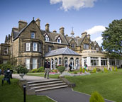
Cost: Members £265, Non - members £280.
..........................................................................................

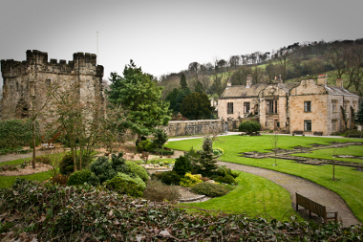
Spring Break. 9th - 13th April 2018. Whalley Abbey Retreat and Conference House, Whalley, Clitheroe, Lancashire.
We are returning to this lovely venue in the Lancashire countryside, where we have enjoyed a previous stay
Cost: members £275, Non- members £290
..............................................................................................

Summer Holiday. 6th - 13th July 2018
The greenhouse Christian Centre, Poole
Last years holiday was so popular we are returning in 2018!
Cost: members £ 415, Non- members £435 (Limited number of en-suite rooms available for an additional charge of £20)

A Deposit of £25 is required for each holiday, with the balance payable by four weeks before the start of the holiday, booking forms and booking conditions can be downloaded from our website. christiansinglesfellowship.co.uk
For further enquiries please contact - Brenda 01204 669764 or Howard 012998 78759
Please note that guests are solely responsible for their own travel arrangements to and from the venues.

